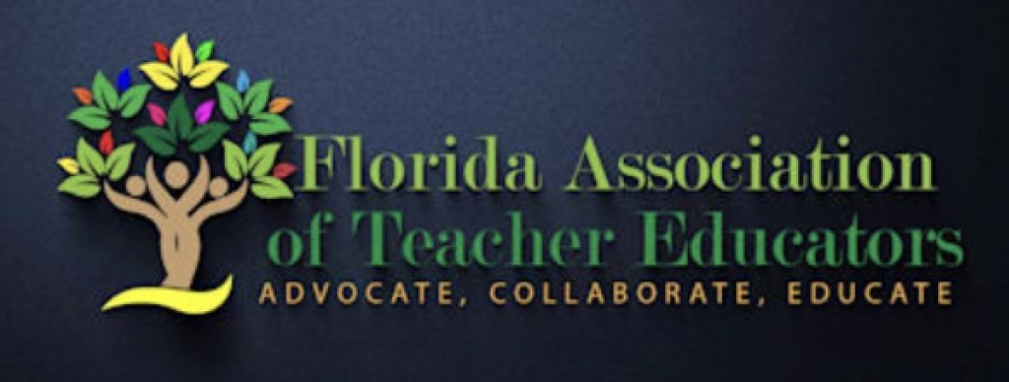
Mary L. Collins Award
Excellence in Teacher Education 2021

The Mary L. Collins Award for Excellence in Teacher Education is presented each year to an educator who has made significant and substantial contributions to teacher education in Florida. The award, established in 2000, is named for Dr. Mary Collins, Professor of Teacher Education in the Fischler Graduate School of Education at Nova Southeastern University. Dr. Collins is responsible for the revitalization of FATE and has made many contributions to teacher education at the state, regional and national levels.

The nomination must originate from a FATE member. The Standards for Teacher Educators, published by the Association of Teacher Educators (ATE) should be taken into consideration when completing the nomination. These standards can be reviewed on the Webpage: https://ate1.org/standards-for-teacher-educators

Award Criteria
Standards for this award include, but are not limited to, an educator who:
- Models professional teaching practices which demonstrate knowledge, skills and attitudes reflecting best practice;
- Inquires into and contributes to one or more areas of scholarly activity that are related to teaching, learning, and/or teacher education;
- Inquires systematically into, and reflects on, their own practice and demonstrates commitment to lifelong professional development;
- Provides leadership in developing, implementing, and evaluating programs for educating teachers that embrace diversity, and are rigorous, relevant, and grounded in best practice;
- Collaborates regularly with school, university, state education department, professional associations, and community representatives to improve teaching, learning and teacher education;
- Serves as an informed, constructively critical advocate for high quality education for all students, public understanding of educational issues, and excellence and diversity in teaching and teacher education professions; and
- Contributes to improving the teacher education profession.

Nomination and Selection
Nomination packets for the Mary L. Collins Award for Excellence in Teacher Education may be submitted electronically or paper copy to:
Electronic copy:  Dr. Valerie Wright  Awards Committee Chair  Valerie.wright@saintleo.edu | Paper copy:  Dr. Valerie Wright  Saint Leo University  33701 State Road 52  St. Leo, FL 33574

Notification of received nominations will be sent via email.
The deadline for receipt of the Nomination Packet is Friday, October 29, 2021

Nomination Package:
- A cover page to include: nominee's name, address and telephone number, name and address of employer, job title with description of responsibilities,
- A résumé or vitae of the nominee,
- A nominating letter from a FATE member (detailing why the nominee should receive the award), and
- Supporting letters (a minimum of two).

Selection
Applicants will be assessed by their ability to meet the standards required of a distinguished teacher educator.
The award recipient will be notified by November 5, 2021 approximately one month prior to the FATE Annual Conference where s/he will be honored during the Awards Luncheon on Saturday, December 4, 2021.
As a special guest of the conference, the recipient will receive complimentary conference registration. The recipient will also receive a plaque and will have their name engraved on a circulating plaque that includes the names of past recipients.

Please direct questions to:
Dr. Valerie Wright
Saint Leo University
33701 State Road 52
St. Leo, FL 33574
352-588-8906

Thank you in advance for promoting quality teacher education

